

| E-commerce Product Catalog | |
| --- | --- |
| NAVODITA INFOTECH INTERN NAME - KHUSHAL RAVINDRA SALVE  INTERN ID - N242503553 |  |
| Summary The internship in Frontend Development provided an enriching and hands-on experience in the realm of web development. Over the course of the internship, I had the opportunity to work with a dynamic team of developers, contributing to various projects and tasks that enhanced my technical skills and understanding of frontend technologies.  Key aspects of the internship included:   1. **Project Work:** Engaging in real-world projects allowed me to apply theoretical knowledge to practical scenarios. From designing responsive layouts to implementing interactive user interfaces, each project presented unique challenges and learning opportunities. 2. **Collaboration**: Working alongside experienced developers fostered a collaborative environment where ideas were shared, feedback was given, and solutions were collectively developed. This collaborative approach not only improved project outcomes but also accelerated my learning curve. 3. **Technical Skills Development:** The internship provided exposure to a wide range of frontend technologies, including HTML, CSS, JavaScript, and popular frameworks like React.js and Vue.js. Through hands-on experience and guided mentorship, I honed my coding skills and gained proficiency in using development tools and libraries. 4. **Problem-solving:** Encountering challenges and obstacles along the way was an integral part of the internship experience. These challenges pushed me to think critically, troubleshoot effectively, and explore innovative solutions, ultimately strengthening my problem-solving abilities. 5. **Professional Growth:** Beyond technical skills, the internship facilitated my professional growth by enhancing communication skills, time management, and the ability to work effectively in a team-oriented environment. Engaging with clients, meeting project deadlines, and adapting to changing requirements were valuable experiences that contributed to my overall development.   Frontend Development provided a comprehensive learning journey that combined theoretical knowledge with practical application. It equipped me with the skills, experience, and confidence needed to excel in the field of web development and prepared me for future endeavors in the ever-evolving world of technology. |  |

|  |  |  |
| --- | --- | --- |
| INTRODUCTION | | |
| E-commerce has revolutionized the way businesses engage with customers and conduct transactions. With the exponential growth of online shopping, the demand for robust and user-friendly e-commerce platforms has never been higher. Frontend Development plays a pivotal role in shaping the digital storefronts that drive the online shopping experience, from captivating product displays to seamless navigation and intuitive user interfaces..  This internship report provides a comprehensive overview of my experience in Frontend Development, with a specific focus on "E-commerce Catalog Development." Throughout the internship, I had the opportunity to delve into the dynamic world of web development and contribute to the creation of an immersive and interactive e-commerce catalog. By leveraging a combination of technical skills, creativity, and problem-solving abilities, I embarked on the journey of translating design concepts into functional and visually stunning web interfaces.  The internship entailed a diverse range of tasks and responsibilities, including user interface design, product presentation, navigation optimization, performance tuning, and integration with backend systems. Through collaborative efforts with cross-functional teams and guided mentorship, I navigated through the intricacies of frontend development, overcoming challenges and delivering solutions that met the objectives of the project.  This report aims to provide insights into the process, methodologies, and outcomes of the internship, highlighting key learnings, achievements, and reflections. By documenting my journey in "E-commerce Catalog Development," I seek to showcase the value of frontend development in enhancing the online shopping experience and driving business growth in the digital landscape. | | |
| Project Overview | | |
| The "E-commerce Catalog Development" project aimed to create a visually appealing and user-friendly online catalog for an e-commerce platform. The project's primary objective was to design and implement frontend components that would enhance the browsing and shopping experience for customers, ultimately driving engagement and sales.  Key aspects of the project included:   1. **Scope:** The project scope encompassed the development of an extensive catalog that showcased a diverse range of products across multiple categories. The catalog would serve as the digital storefront, allowing customers to browse, search, and explore products with ease. 2. **Objectives:** The main objectives of the project were to:    * Design an intuitive and responsive user interface that would provide seamless navigation and accessibility across devices.    * Create visually compelling product listings with high-quality images, detailed descriptions, and interactive elements to engage users.    * Implement functionality for product filtering, sorting, and search to enable users to find products quickly and efficiently.    * Optimize performance to ensure fast page loading times and smooth browsing experiences, enhancing user satisfaction and retention. 3. **Collaboration:** The project involved collaboration with cross-functional teams, including designers, backend developers, and stakeholders. Close coordination was essential to align frontend development efforts with design specifications and backend functionalities. 4. **Methodology:** The project followed an iterative development approach, with continuous feedback loops and incremental updates. Agile methodologies were employed to adapt to changing requirements, prioritize tasks, and deliver value incrementally. 5. **Technologies:** Frontend technologies such as HTML, CSS, JavaScript, and frontend frameworks like React.js or Vue.js were utilized to build the e-commerce catalog. Integration with backend systems, APIs, and databases was also a crucial aspect of the project. 6. **Deliverables:** The primary deliverable of the project was a fully functional e-commerce catalog that met the specified requirements and objectives. This included the frontend codebase, documentation, and any additional assets or resources required for deployment. 7. **Outcomes:** The successful completion of the project resulted in an engaging and user-friendly online catalog that enhanced the overall shopping experience for customers. Key outcomes included improved user engagement, increased conversion rates, and positive feedback from stakeholders and end-users.   In summary, the "E-commerce Catalog Development" project aimed to leverage frontend development expertise to create a compelling digital storefront that would drive customer engagement, facilitate product discovery, and ultimately contribute to the success of the e-commerce platform. | | |  |
|  | | |

Objective of an Internship

The objectives of the Frontend Development internship, focused on "E-commerce Catalog Development," were multi-faceted, aiming to provide a comprehensive learning experience and contribute to the success of the project. Here are the key objectives:

1. **Gain Hands-on Experience:** Acquire practical experience in frontend development by actively participating in the creation of an e-commerce catalog. Apply theoretical knowledge to real-world scenarios and gain exposure to industry-standard tools, technologies, and best practices.
2. **Develop Technical Skills:** Enhance proficiency in frontend technologies such as HTML, CSS, JavaScript, and frontend frameworks (e.g., React.js, Vue.js). Strengthen coding skills, learn new techniques, and expand knowledge of web development concepts, including responsive design and user interface optimization.
3. **Understand E-commerce Dynamics:** Gain insight into the dynamics of the e-commerce industry, including consumer behavior, market trends, and business strategies. Understand the importance of user experience (UX) and user interface (UI) design in driving engagement and conversion rates in an online retail environment.
4. **Contribute to Project Success:** Collaborate with cross-functional teams to contribute to the development and enhancement of the e-commerce catalog. Take ownership of assigned tasks, meet project deadlines, and deliver high-quality frontend components that meet design specifications and user requirements.
5. **Problem-solving and Adaptability:** Develop problem-solving skills and the ability to adapt to evolving project requirements and challenges. Overcome technical hurdles, troubleshoot issues, and explore innovative solutions to optimize frontend performance and user experience.
6. **Professional Growth**: Foster personal and professional growth through continuous learning, feedback, and self-reflection. Improve communication skills, teamwork, and time management abilities while working in a collaborative and dynamic environment.
7. **Create Impact**: Make a tangible impact on the project by delivering solutions that enhance the functionality, usability, and visual appeal of the e-commerce catalog. Contribute to the project's success and demonstrate the value of frontend development in driving business objectives and customer satisfaction.
8. Overall, the objectives of the internship were aimed at providing a valuable learning experience, fostering skill development, and making meaningful contributions to the "E-commerce Catalog Development" project while preparing for future career opportunities in frontend development and related fields.

## Tools and Techonology is Used

In the "E-commerce Catalog Development" project, a variety of tools and technologies were utilized to facilitate frontend development and create an engaging online shopping experience. Here are some of the key tools and technologies used:

1. **HTML (HyperText Markup Language):** HTML was used to structure the content of web pages, defining the layout and hierarchy of elements such as headings, paragraphs, images, and links.
2. **CSS (Cascading Style Sheets):** CSS was employed to style and format the HTML elements, controlling aspects such as color, font, layout, and responsiveness. CSS frameworks like Bootstrap or Tailwind CSS may have been utilized to expedite styling and ensure consistency across the website.
3. **JavaScript:** JavaScript was used to add interactivity and dynamic behavior to the web pages. It was utilized to implement features such as product filtering, sorting, search functionality, and interactive elements like carousels, modals, and dropdown menus.
4. **Frontend Frameworks**: Frontend frameworks like React.js or Vue.js may have been utilized to build reusable components and manage complex user interfaces efficiently. These frameworks provide tools and libraries for state management, routing, and data fetching, enabling faster development and improved maintainability.
5. **Version Control Systems:** Version control systems such as Git were used to manage and track changes to the codebase collaboratively. Platforms like GitHub or GitLab may have been utilized for code hosting, issue tracking, and project management.
6. **Code Editors:** Code editors like Visual Studio Code, Sublime Text, or Atom were used to write, edit, and debug frontend code. These editors provide features such as syntax highlighting, code completion, and integrated terminal support, enhancing productivity and efficiency.
7. **Browser Developer Tools**: Browser developer tools (e.g., Chrome DevTools, Firefox Developer Tools) were utilized for testing, debugging, and optimizing frontend code. These tools provide insights into page performance, layout, and network activity, aiding in troubleshooting and optimization efforts.
8. **Responsive Design Testing Tools**: Tools like BrowserStack or Responsinator were used to test the responsiveness of the website across various devices and screen sizes. These tools simulate different viewports and environments, helping ensure a consistent and user-friendly experience for all users

.

1. **Task Runners and Build Tools**: Task runners like Gulp or build tools like Webpack may have been used to automate repetitive tasks, optimize assets, and streamline the development workflow. These tools improve efficiency and maintainability by automating tasks such as code minification, image optimization, and dependency management.
2. **API Integration:** Frontend development may have involved integration with backend systems and APIs to retrieve and display product data, manage user authentication, process transactions, and perform other server-side operations. Technologies such as RESTful APIs or GraphQL may have been utilized for data communication.

By leveraging these tools and technologies, the frontend development team was able to create a robust, scalable, and user-friendly e-commerce catalog that met the project objectives and provided a seamless shopping experience for users.

## Internship Experiance

The Frontend Development internship in "E-commerce Catalog Development" was a transformative experience characterized by hands-on learning, collaboration, and continuous growth. Working alongside experienced developers and cross-functional teams, I gained practical experience in web development while tackling real-world projects. Throughout the internship, I took ownership of tasks, embraced challenges as learning opportunities, and honed my technical skills and problem-solving abilities. The supportive environment, mentorship, and feedback sessions facilitated my professional development, preparing me for future career opportunities in frontend development. Reflecting on the internship, I am proud of the progress I've made and the contributions I've made to the project, reaffirming my passion for frontend development and my commitment to continuous learning and growth in the field.

**Overview Of Company/Organization-**

Navodita Infotech is a dynamic and innovative information technology (IT) company at the forefront of technological advancements. Established with a commitment to excellence, Navodita Infotech has built a reputation for delivering cutting-edge IT solutions and services that empower businesses to thrive in the digital age.

Website

<https://navoditainfotech.com/>

Industry

IT Services and IT Consulting

Company size

201-500 employees

[60 associated members](https://www.linkedin.com/search/results/people/?currentCompany=%5B%2299953631%22%5D&origin=COMPANY_PAGE_CANNED_SEARCH)

LinkedIn members who’ve listed Navodita Infotech as their current workplace on

their profile.

Headquarters

Pune, Maharashtra

**Role And Responsibility**

During the Frontend Development internship focused on "E-commerce Catalog Development," my role encompassed a range of responsibilities aimed at contributing to the creation of an engaging and user-friendly online shopping experience. Here are the key roles and responsibilities I undertook:

* **User Interface Design**: Collaborated with the design team to translate design mockups and wireframes into visually appealing and intuitive user interfaces. Developed layouts, components, and visual elements using HTML, CSS, and JavaScript to enhance the frontend aesthetics and usability.
* **Frontend Development:** Implemented frontend components and features to enhance the functionality and interactivity of the e-commerce catalog. Developed product listings, navigation menus, search functionality, and interactive elements using frontend frameworks like React.js or Vue.js.
* **Responsive Design:** Ensured that the e-commerce catalog was responsive and optimized for various devices and screen sizes. Implemented responsive design techniques and media queries to adapt the layout and content presentation based on viewport dimensions, enhancing the user experience across desktop, tablet, and mobile devices.
* **Product Presentation:** Worked on showcasing products effectively within the catalog, including integrating high-quality images, detailed product descriptions, pricing information, and interactive elements like product filters, sorting options, and related product suggestions.
* **Performance Optimization**: Optimized frontend code and assets to improve page loading times and overall site performance. Implemented best practices for code minification, image optimization, lazy loading, and caching to enhance site speed and user experience.
* **Integration with Backend Systems**: Collaborated with backend developers to integrate frontend components with backend systems and APIs. Implemented data retrieval, update, and synchronization functionalities to ensure real-time availability of product information and seamless communication between frontend and backend.
* **Testing and Debugging:** Conducted thorough testing and debugging of frontend code to identify and address issues related to functionality, layout, and performance. Utilized browser developer tools, automated testing frameworks, and manual testing techniques to ensure the stability and reliability of the e-commerce catalog.
* **Documentation and Reporting:** Maintained documentation of frontend development processes, including code documentation, project specifications, and development guidelines. Generated reports on project progress, challenges encountered, and solutions implemented, facilitating communication and knowledge sharing within the team.

Overall, my role and responsibilities in the Frontend Development internship revolved around creating a compelling and user-friendly e-commerce catalog through effective user interface design, frontend development, performance optimization, and integration with backend systems.

## Technical Skill Aquried

During the Frontend Development internship focused on "E-commerce Catalog Development," I acquired a diverse range of technical skills that enhanced my proficiency in web development and frontend technologies. Here are the key technical skills I acquired:

* **HTML**: Developed a strong understanding of HTML (HyperText Markup Language) and its role in structuring the content of web pages. Learned to create semantic HTML markup for various elements such as headings, paragraphs, lists, and forms.
* **CSS:** Gained expertise in CSS (Cascading Style Sheets) for styling and formatting web pages. Learned CSS syntax, selectors, properties, and values to apply custom styles, layouts, colors, fonts, and animations to HTML elements.
* **JavaScript**: Acquired proficiency in JavaScript, the programming language of the web, for adding interactivity and dynamic behavior to web pages. Learned JavaScript fundamentals, including variables, data types, functions, loops, conditionals, and DOM manipulation.
* **Frontend Frameworks:** Explored frontend frameworks such as React.js or Vue.js to build reusable and modular components for building user interfaces. Learned concepts such as component-based architecture, state management, routing, and lifecycle methods.
* **Browser Developer Tools:** Learned to use browser developer tools (e.g., Chrome DevTools, Firefox Developer Tools) for testing, debugging, and optimizing frontend code. Explored features such as element inspection, console logging, network analysis, and performance profiling.

Overall, the internship provided a comprehensive learning experience that equipped me with the technical skills and knowledge needed to excel in frontend development and contribute effectively to the creation of user-friendly and visually appealing web interfaces.

**Challenges Faced**

During the implementation of the "E-commerce Catalog Development" project, several challenges were encountered, requiring problem-solving and adaptability to overcome. Here are some of the key challenges faced:

* Cross-browser Compatibility: Ensuring consistent behavior and appearance across different web browsers (e.g., Chrome, Firefox, Safari) proved challenging due to variations in rendering engines and CSS support. Resolving browser-specific issues required thorough testing and targeted CSS adjustments.
* Responsive Design Complexity: Implementing responsive design for the e-commerce catalog posed challenges in maintaining layout consistency and usability across various viewport sizes and devices. Balancing design aesthetics with functionality on small screens while avoiding clutter and information overload was a significant challenge.
* Performance Optimization: Optimizing the performance of the e-commerce catalog to ensure fast page loading times and smooth user experience presented challenges. Managing large volumes of product data, images, and assets while minimizing HTTP requests and reducing page weight required careful optimization techniques.
* Integration with Backend Systems: Integrating frontend components with backend systems and APIs posed challenges in data retrieval, synchronization, and error handling. Addressing issues related to data consistency, authentication, and handling of asynchronous requests required coordination between frontend and backend developers.
* Complex Interactivity Requirements: Implementing complex interactive features such as product filtering, sorting, and search functionality posed challenges in terms of user experience design and technical implementation. Balancing functionality, performance, and usability while ensuring a seamless user experience required iterative refinement and testing.
* Dynamic Content Rendering: Rendering dynamic content such as product listings, images, and descriptions dynamically from backend data presented challenges in data management, caching, and data consistency. Implementing efficient data fetching and rendering strategies while minimizing latency and server load was crucial.
* User Interface Consistency: Maintaining consistency in user interface elements, styles, and interactions across different sections of the e-commerce catalog posed challenges. Ensuring visual coherence, adherence to brand guidelines, and consistency in user experience design required meticulous attention to detail and adherence to design specifications.
* Version Control and Collaboration: Managing changes to the codebase collaboratively using version control systems like Git presented challenges, particularly in resolving conflicts and ensuring code consistency. Effective communication, branching strategies, and code review processes were essential for smooth collaboration.

Solution Implemented

Despite these challenges, proactive problem-solving, collaboration, and perseverance enabled the successful implementation of the e-commerce catalog, resulting in an engaging and user-friendly online shopping experience for customers. Each challenge presented an opportunity for learning and growth, ultimately contributing to the development of valuable skills and expertise in frontend development.

To address the challenges faced during the implementation of the "E-commerce Catalog Development" project, several solutions were implemented. Here's how each challenge was tackled:

1. Cross-browser Compatibility:
   * Conducted thorough testing across multiple web browsers and devices to identify compatibility issues.
   * Utilized CSS vendor prefixes, polyfills, and feature detection techniques to ensure consistent rendering and behavior across browsers.
   * Employed browser-specific CSS hacks or conditional stylesheets as a last resort for targeting specific browser quirks.
2. Responsive Design Complexity:
   * Utilized a mobile-first approach, designing and developing the e-commerce catalog with small screens in mind before scaling up to larger viewports.
   * Implemented fluid grid layouts, flexible images, and responsive typography to create adaptable and visually appealing designs.
   * Employed CSS media queries and breakpoints strategically to adjust layout, content, and functionality based on viewport size.
3. Performance Optimization:
   * Minified and concatenated CSS and JavaScript files to reduce file size and improve load times.
   * Optimized image assets by compressing images, using responsive image formats, and lazy loading techniques.
   * Implemented caching mechanisms, CDN (Content Delivery Network) integration, and server-side optimizations to reduce latency and improve server response times.
4. Integration with Backend Systems:
   * Established clear communication channels and documentation standards between frontend and backend teams to ensure alignment on data formats, endpoints, and authentication mechanisms.
   * Implemented error handling and graceful degradation strategies to handle network errors, server failures, and data inconsistencies gracefully.
   * Utilized libraries and frameworks (e.g., Axios, Fetch API) for making asynchronous requests and managing responses efficiently.
5. Complex Interactivity Requirements:
   * Broke down complex interactive features into smaller, manageable components and functionalities to simplify implementation and testing.
   * Conducted user testing and feedback sessions to gather insights and iteratively refine interactive features based on user behavior and preferences.
   * Leveraged frontend frameworks and libraries (e.g., React.js, Vue.js) to streamline development and manage stateful components effectively.
6. Dynamic Content Rendering:
   * Implemented client-side rendering techniques to render dynamic content efficiently without requiring full-page reloads.
   * Utilized client-side caching mechanisms and data prefetching strategies to minimize data retrieval latency and improve perceived performance.
   * Employed server-side rendering (SSR) or progressive enhancement techniques for enhanced performance and accessibility in scenarios where client-side rendering was not feasible.
7. User Interface Consistency:
   * Established a design system or style guide to maintain consistency in UI elements, visual styles, and interaction patterns throughout the e-commerce catalog.
   * Conducted regular design reviews and audits to ensure adherence to design guidelines and identify areas for improvement or standardization.
   * Utilized CSS preprocessors or design tokens for centralizing and managing UI styles and variables to facilitate consistent UI development.
8. Version Control and Collaboration:
   * Implemented a branching strategy and workflow using Git (e.g., feature branching, pull requests) to facilitate collaborative development and code review processes.
   * Established coding standards and conventions to maintain code consistency and readability across contributors.
   * Utilized collaboration tools (e.g., GitHub, GitLab, Slack) for communication, issue tracking, and project management to streamline collaboration and workflow.

By implementing these solutions, the challenges encountered during the implementation of the "E-commerce Catalog Development" project were effectively addressed, leading to the successful delivery of a high-quality, performant, and user-friendly e-commerce catalog.

**Result**

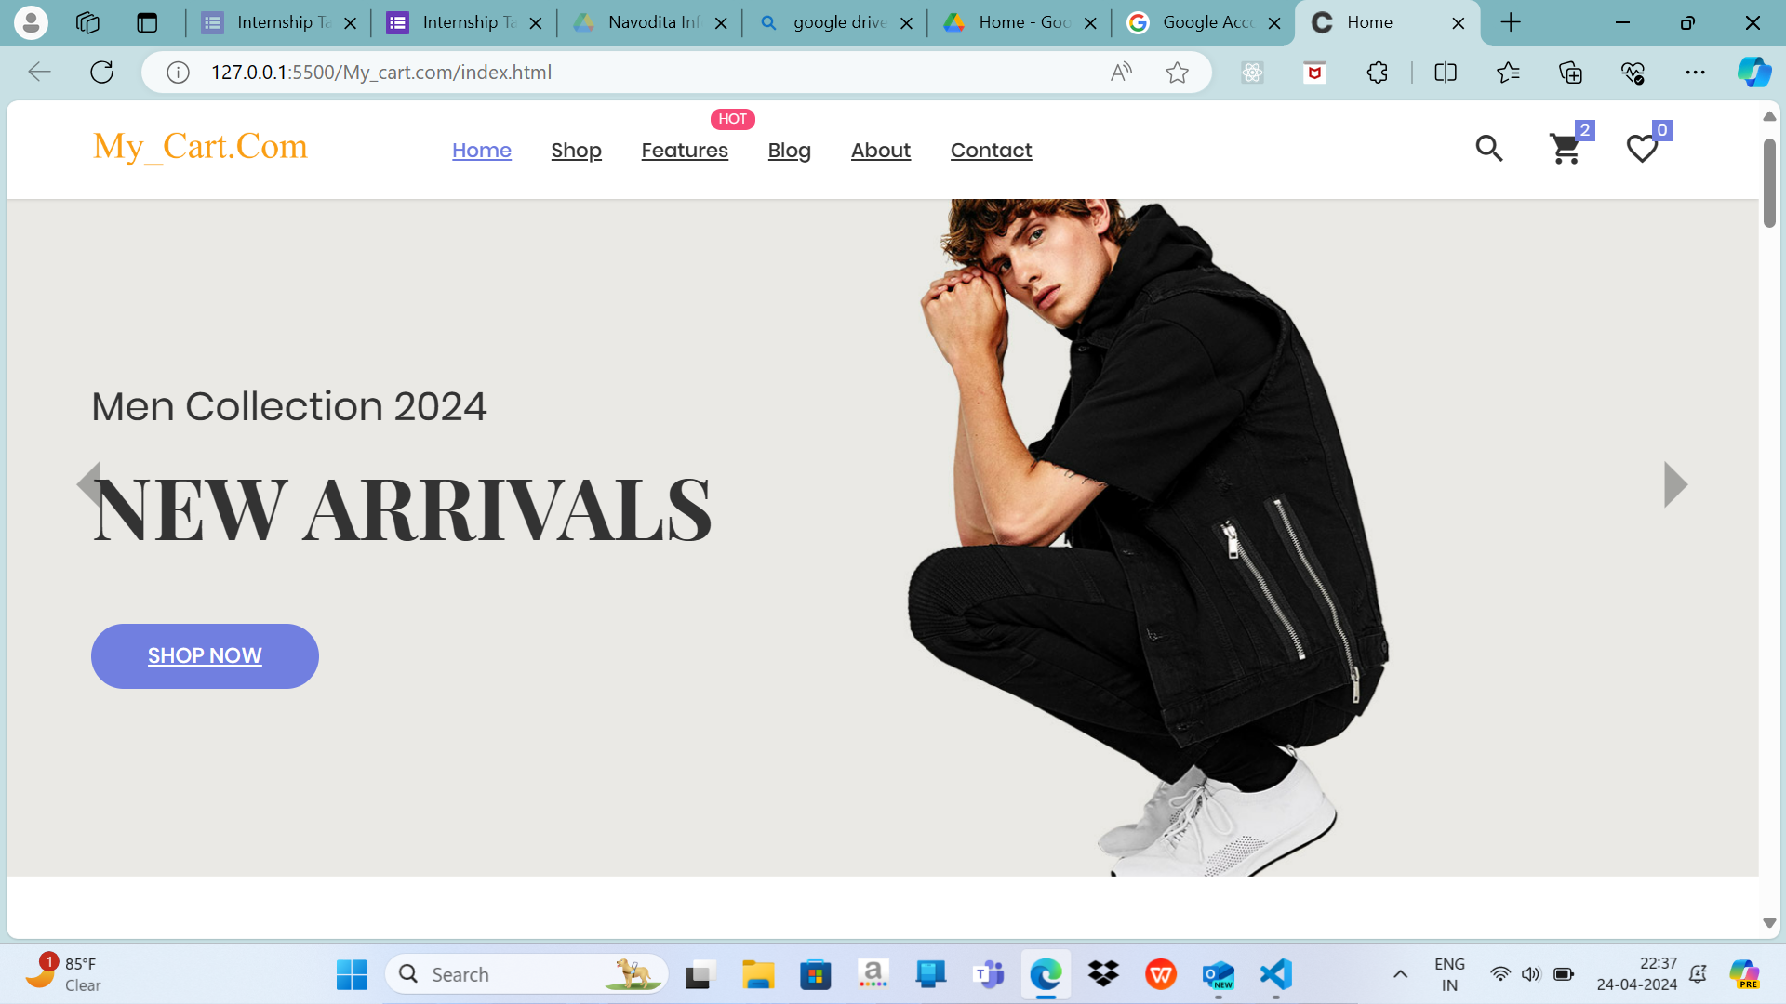

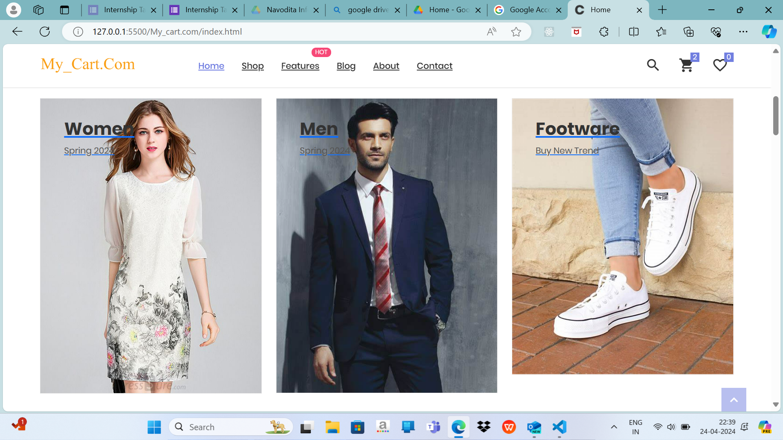

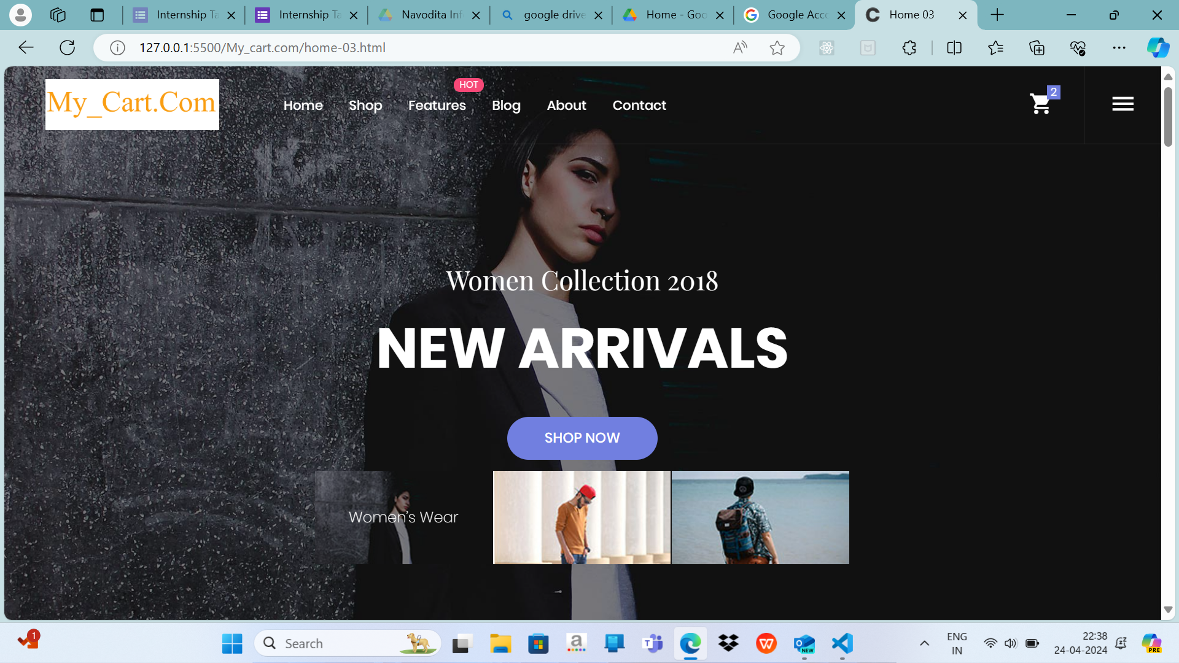

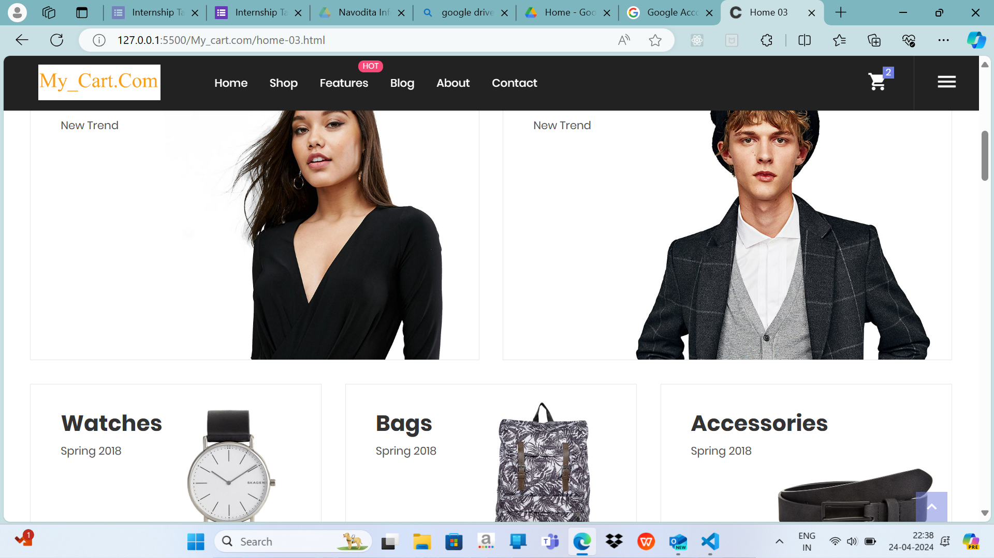

**Lession Learning**

Here are some key lessons learned from the experience:

* Adaptability: Being adaptable and flexible in the face of changing requirements or unexpected challenges is crucial. The ability to pivot and adjust strategies when necessary ensures progress and success in dynamic environments.
* Communication: Effective communication is vital for project success. Clear and open communication fosters collaboration, aligns expectations, and helps overcome obstacles more efficiently.
* Time Management: Prioritizing tasks and managing time effectively is essential to meet deadlines and deliverables. Learning to balance multiple responsibilities and allocate time appropriately improves productivity and reduces stress.
* Problem-solving Skills: Every project comes with its unique set of challenges. Developing strong problem-solving skills and a proactive attitude towards finding solutions is invaluable in navigating obstacles and achieving goals.
* Continuous Learning: The field of technology is constantly evolving, so embracing a mindset of continuous learning is essential. Staying updated on new tools, techniques, and industry trends ensures relevance and growth in the field.
* Feedback: Seeking and providing constructive feedback is essential for personal and professional development. Embracing feedback as an opportunity for improvement fosters growth and drives excellence in work.

.

* Resilience: Facing setbacks and challenges is inevitable, but resilience is key to overcoming them. Maintaining a positive attitude, learning from failures, and persisting in the face of adversity ultimately leads to growth and success.

Overall, the internship provided valuable lessons that have enhanced skills, fostered personal growth, and prepared for future opportunities in the field of frontend development. These lessons serve as a foundation for continued learning, improvement, and success in the ever-evolving technology landscape.

**Reflection on Internship Experiance**

Reflecting on the internship experience in Frontend Development, it has been a transformative journey filled with learning, growth, and valuable insights. Here are some reflections on the internship experience:

* Technical Growth: The internship provided an opportunity to deepen understanding and proficiency in frontend technologies such as HTML, CSS, JavaScript, and frameworks like React.js. Through hands-on projects and challenges, I gained practical experience in building user-friendly web interfaces and implementing interactive features.
* Problem-solving Skills: Facing various challenges during the internship, I developed strong problem-solving skills and learned to approach issues with creativity and perseverance. Each obstacle became an opportunity to learn, innovate, and find solutions, contributing to personal and professional development.
* Collaborative Environment: Working in a collaborative environment with cross-functional teams fostered teamwork, communication, and collaboration skills. Engaging in discussions, sharing ideas, and receiving feedback from peers and mentors enriched the learning experience and enhanced project outcomes.
* Time Management: Balancing multiple tasks and deadlines throughout the internship honed time management and prioritization skills. Learning to manage time effectively, set realistic goals, and allocate resources efficiently was crucial in meeting project milestones and delivering quality work.
* Continuous Learning: The internship reinforced the importance of continuous learning and staying updated on emerging technologies and industry trends. Engaging in self-directed learning, exploring new tools and techniques, and seeking opportunities for growth were integral to staying relevant in the fast-paced field of frontend development.
* Professional Growth: The internship provided a platform for professional growth, allowing me to develop leadership qualities, communication skills, and a strong work ethic. Taking ownership of tasks, collaborating with team members, and delivering results with integrity and accountability were key aspects of professional development.
* Personal Reflection: Beyond technical skills, the internship prompted personal reflection and self-discovery. It offered insights into strengths, areas for improvement, and career aspirations, guiding future career paths and goals in frontend development.

Overall, the internship experience was enriching and rewarding, laying a strong foundation for continued growth and success in the field of frontend development. It instilled a passion for lifelong learning, collaboration, and innovation, shaping not only professional skills but also personal values and aspirations.

## **Conclusion :**

In conclusion, the Frontend Development internship experience has been immensely valuable, providing a platform for growth, learning, and personal development. Throughout the internship, I had the opportunity to deepen my technical skills, enhance problem-solving abilities, and cultivate a collaborative mindset in a dynamic and challenging environment.

The internship reaffirmed the importance of continuous learning and adaptability in the ever-evolving field of frontend development. It emphasized the significance of effective communication, teamwork, and time management in achieving project objectives and delivering high-quality work.

Reflecting on the internship experience, I am grateful for the opportunities, challenges, and lessons learned along the way. It has equipped me with the skills, knowledge, and confidence needed to embark on future endeavors in frontend development with enthusiasm and determination.

Moving forward, I am committed to applying the lessons learned and building upon the experiences gained during the internship. I am excited to continue my journey of growth, exploration, and contribution to the field of frontend development, embracing new challenges and opportunities with optimism and resilience.

Overall, the internship has been a transformative experience that has not only shaped my professional skills but also enriched my personal growth and aspirations. I am thankful for the support, guidance, and mentorship received throughout the internship, and I look forward to applying the learnings and insights gained to make meaningful contributions in the frontend development community.

**References**

When referencing the "E-commerce Catalog Development" project for your internship report, you'll want to include any sources, materials, or tools that you used during the project. Here's an example of how you might format the references section:

References

1. W3Schools. (n.d.). HTML Tutorial. Retrieved from https://www.w3schools.com/html/
2. Mozilla Developer Network. (n.d.). CSS. Retrieved from<https://developer.mozilla.org/en-US/docs/Web/CSS>
3. React. (n.d.). A JavaScript library for building user interfaces. Retrieved from<https://reactjs.org/>
4. Bootstrap. (n.d.). The most popular HTML, CSS, and JavaScript framework for developing responsive, mobile-first websites. Retrieved from<https://getbootstrap.com/>
5. GitHub. (n.d.). Where the world builds software. Retrieved from<https://github.com/>
6. Stack Overflow. (n.d.). Question and Answer site for professional and enthusiast programmers. Retrieved from<https://stackoverflow.com/>
7. Web.dev. (n.d.). Learn web development. Retrieved from<https://web.dev/>
8. FreeCodeCamp. (n.d.). Learn to code for free. Retrieved from<https://www.freecodecamp.org/>
9. GitLab. (n.d.). Create, review, and deploy code together. Retrieved from<https://about.gitlab.com/>
10. Google Developers. (n.d.). Web Fundamentals. Retrieved from<https://developers.google.com/web/fundamentals>

Ensure to replace "(n.d.)" with the publication date if available, and adjust the format according to your citation style guide (e.g., APA, MLA). Additionally, include any specific resources, tutorials, or documentation that were particularly helpful during the project.

**Appendices**

Appendix A: Project Wireframes

* A collection of wireframe sketches or digital mockups illustrating the planned layout, structure, and user interface design of the e-commerce catalog.

Appendix B: Code Snippets

* Selected snippets of HTML, CSS, JavaScript, or frontend framework code used in the development of the e-commerce catalog, demonstrating key functionalities or design elements.

Appendix C: Project Timeline

* A timeline or Gantt chart outlining the key milestones, tasks, and deadlines associated with the development of the e-commerce catalog.

**Appendix D